# 

# A

# Mini-Project Report

**on**

## IOT BASED SMART STREET LIGHT SYSTEM

### **Submitted as partial fulfilment for the award of**

#### **BACHELOR OF TECHNOLOGY DEGREE**

**Session 2021-22**

**in**

###### **Computer Science & Engineering**

**Submitted By:**

**RIYA GUPTA Roll.No:85**

**SHASHANK SRIVASTAVA Roll.No:100**

**PRIYESH GUPTA Roll.No:81**

**SHEETAL TYAGI Roll.No:103**

**PRIYA YADAV Roll.No:80**

**Under the guidance of:**

**Ms. Tanu Shree**

### **Assistant Professor**



**DEPARTMENT OF COMPUTER SCIENCE AND ENGINEERING**

**GALGOTIAS COLLEGE OF ENGINEERING AND TECHNOLOGY, GREATER NOIDA**



**AFFILIATED TO**

**DR. A.P.J ABDUL KALAM TECHNICAL UNIVERSITY, LUCKNOW, UP**

|  |  |
| --- | --- |
| **GEI logo** | **GALGOTIAS COLLEGE OF ENGINEERING & TECHNOLOGY**  **GREATER NOIDA, UTTER PRADESH, INDIA- 201306.** |

# CERTIFICATE

This is to certify that the mini-project report entitled “**IOT BASED SMART STREET LIGHT SYSTEM**” submitted by Ms. **RIYA GUPTA (Roll.No:85)** Mr. **SHASHANK SRIVASTAVA (Roll.No:100),** Mr. **PRIYESH GUPTA (Roll.No:81),** Ms. **SHEETAL TYAGI (Roll.No:103),** Ms. **PRIYA YADAV (Roll.No:80)** to the Galgotias College of Engineering & Technology, Greater Noida, Utter Pradesh, affiliated to Dr. A.P.J. Abdul Kalam Technical University Lucknow, Uttar Pradesh in partial fulfillment for the award of Degree of Bachelor of Technology in Computer science & Engineering is a bonafide record of the project work carried out by them under my supervision during the year 2021-2022.

|  |  |
| --- | --- |
| **Ms. Tanu Shree**  **Assistant Professor**  **Deptt. of CSE** | **Dr. Vishnu Sharma**  **Professor and Head**  **Deptt. of CSE** |

|  |  |
| --- | --- |
| **GEI logo** | **GALGOTIAS COLLEGE OF ENGINEERING & TECHNOLOGY**  **GREATER NOIDA, UTTER PRADESH, INDIA- 201306.** |

# ACKNOWLEDGEMENT

We have taken efforts in this project. However, it would not have been possible without the kind support and help of many individuals and organizations. We would like to extend my sincere thanks to all of them.

We are highly indebted to **Mr. Ravikant Nirala** for his guidance and constant supervision. Also, we are highly thankful to him for providing necessary information regarding the project & also for his support in completing the project.

We are extremely indebted to **Dr. Vishnu Sharma**, HOD, Department of Computer Science and Engineering, GCET and **Ms. Tanu Shree**, Project Coordinator, Department of Computer Science and Engineering, GCET for their valuable suggestions and constant support throughout my project tenure. We would also like to express our sincere thanks to all faculty and staff members of Department of Computer Science and Engineering, GCET for their support in completing this project on time.

We also express gratitude towards our parents for their kind co-operation and encouragement which helped me in completion of this project. Our thanks and appreciations also go to our friends in developing the project and all the people who have willingly helped me out with their abilities.

Riya Gupta

Shashank Srivastava

Priyesh Gupta

Sheetal Tyagi

Priya Yadav

# ABSTRACT

Our project for developing a smart street light system is reviewed. In this project, the street light system, in which lights on when needed and light-off when not needed. Currently, in the whole world, enormous electric energy is consumed by the street lamps, which are automatically turn on when it becomes dark and automatically turn off when it becomes bright. This is the huge waste of energy in the whole world and should be changed. Our smart street light system consists of a LED light, a brightness sensor, LDR, a motion sensor, Obstacle detection and a short-distance communication network. The lights turn on before pedestrians and vehicles come and turn off or reduce power when there is no one. It will be difficult for pedestrians and drivers of vehicles to distinguish our smart street lamps and the conventional street lights, since our street lamps all turn on before they come. The present status and the future prospects of our smart start light project will be reviewed. The ideal behavior of the smart street light system is that no one finds turn-off of street lights at night. Whenever someone see street lights, they turn on and whenever no one see street lights, they turn off. The smart street light system consists of LED lights, brightness sensors, motion sensors and short-distance communication networks. The lights turn on before pedestrians and vehicles come and turn off or reduce brightness when there is no one. It will be difficult for pedestrians and drivers of vehicles to distinguish our smart street lights and the conventional street lights because our street lights all turn on before they come. smart street Light spotlights on different restriction and difficulties identified with traditional and old street lights that are confronted now days and the answer for the deal with those issues by embracing the vision of a smart street light. The noteworthiness of this vision is a completely mechanized bidirectional force conveyance of power and information between the road lights and all the directions in the middle". smart street lights are vitality effective as we, as extremely dependable. The primary thought in the present field advances are computerizations, power utilization, and expense adequacy. Automation is implied for the decrease of labor as the human has gotten to be excessively occupied and even incapable' making it impossible to discover time to switch the lights. Presently a day's everybody are mindful of the availability of limited power sources like coal, biomass, and hydro and so on' unnecessary wastage of power in the street rights is one of the noticeable power loss.

Two sensors viz. The light dependent resistor (LDR) and object sensor which are utilized as a part of the smart street light framework to recognize day and light and distinguish the movement of walker and vehicle separately.

The LDR identifies the vicinity of daylight and naturally turn off the street lights in the day time and turn it on without daylight which decrease the issue of manual switching of road lights. The object sensors identifies the movement of any object and offer command to the microcontroller to glow the road lights with 100% intensity and without any movement in the street give command to the microcontroller to glow with 100% of its maximum intensity or off the street light

Here we have utilized an Arduino Uno to control all the command from LDR and object sensor and execute them legitimately. Fundamentally it acts as the mind of the entire framework.

**KEYWORDS:** LED, LDR, Motion Sensor, obstacle detection, Conventional, Network

**Ⅳ. CONTENTS**

**Title Page No**

**Ⅰ. CERTIFICATE i**

**Ⅱ. ACKNOWLEDGEMENT ii**

**Ⅲ. ABSTRACT iii**

**Ⅳ. CONTENTS iv**

**Ⅴ. LIST OF TABLES v**

**Ⅵ. LIST OF FIGURES vi**

**Ⅶ. NOMENCLATURE vii**

**Ⅷ. ABBREVIATIONS v i i i**

**CHAPTER 1: INTRODUCTION 1**

* 1. Introduction
     1. Motivation
     2. Description

1.2 Background Information

1.3 Chapter Overview

**CHAPTER 2: LITERATURE REVIEW 6**

2.1 Introduction

2.2 Internet of Things

2.3 LED Street light

2.4 Smart Street Light

2.5 Conclusion

**CHAPTER 3: PROBLEM FORMULATION 12**

3.1 Introduction

3.2 Description of Problem Domain

3.3 Problem Statement

3.4 Depiction of problem statement

3.5 Objectives

3.6 Conclusion

**CHAPTER 4: METHODOLOGY 16**

4.2 Proposed work

4.3 System Design

4.3.1 Functional specification of system

4.3 Features

4.5 Components Used

4.6 Overview on Arduino

4.7 Conclusion

**CHAPTER 5: IMPLIMENTATION 30**

5.1 Introduction

5.2 Circuit Design

5.3 Implementation

5.4 Conclusion

**CHAPTER 6: RESULT AND DEMONSTRATION 34**

6.1 Observations and outcomes

**CHAPTER 7: PROJECT RELEVANCE 36**

7.1 Introduction

7.2 Objective and Relevance of the project

7.3 Technical Novelty and Utility

7.4 Expected outcomes

7.5 Concerns Related to Project

**CHAPTER 8: CLOSURE 41**

8.1 Introduction

8.2 Conclusion

8.3 Limitations

8.4 Future Goals

**REFERENCE**

**List of Tables**

|  |  |  |
| --- | --- | --- |
| **S.No** | **Name** | **Page No** |
| 1. | Arduino Specifications | 27 |

**List of Figures**

|  |  |  |
| --- | --- | --- |
| **S.No** | **Name** | **Page No.** |
| 1. | Block Diagram | 14 |
| 2. | Flowchart | 17 |
| 3. | DFD(Level 0) | 18 |
| 4. | DFD(Level 1) | 18 |
| 5. | DFD(Level 2) | 19 |
| 6. | DFD(Level 3) | 19 |
| 7. | LED | 22 |
| 8. | LDR | 22 |
| 9. | IR Sensor | 23 |
| 10. | Breadboard | 25 |
| 11. | Battery Container | 25 |
| 12. | Jumper Wire | 26 |
| 13. | Arduino UNO | 28 |
| 15. | Circuit diagram | 30 |
| 16. | Project Images | 32-33 |
| 17. | IOT vs old street light comparison graph | 35 |

**NOMENCLATURE**

**Iv- candela-**Luminous Intensity

**Ω-ohm-**electrical resistance

**Hz-Hertz-** Frequency

**Qv-lumen second-**Luminous Energy

**W-Watt-**Power

**K.E-Joule-**Kinetic energy

****-**Lambda-**Wavelength

**e-Watt-**Radiant Flux

**v-lumen-**Luminous Flux

**ABBREVIATIONS**

* **IOTs**:- Internet of things
* **LDR:-**light diode resistors
* **SSLS**:- smart street light system
* **LED:-** Light emitting diodes
* **USB:-**universal serial bus
* **IIOT:-**industrial internet of things
* **IR SENSOR:-**Infra red sensors
* **EM WAVE:-** Electromagnetic wave
* **I/O-** Input-Output

**INTRODUCTION**

The street lighting is one of the largest energy expenses for a city. An intelligent street lighting system can cut municipal street lighting costs as much as 50% - 70%.The present system is like the lights will be switched on in the evening before the sun sets and they are switched off the next day morning after there is sufficient light on the outside. But the actual timing for these lights to be switched on are when there is absolute darkness. With this, the power will be wasted up to some extent. In sunny and rainy days, ON and OFF time differ discernibly which is one of the significant hindrances of the present street lights systems. Also the manual operation of the lighting system is completely eliminated.

**1.1 MOTIVATION**

The energy consumption in entire world is increasing at the fastest rates due to population growth and economic development and the availability of energy sources remains woefully constrained. Resource augmentation and growth in energy supply has not kept pace with increasing demand and, therefore, continues to face serious energy shortages. The present framework is similar to, the road lights will be exchanged on in the night prior to the sun sets and they are exchanged off the following day morning after there are adequate lights on the streets. The hindrance of the framework is that we require manual operation of the road light which needs labour. In sunny and rainy days, ON and OFF time differ discernibly which is one of the significant hindrances of the present street lights systems.

Conventional street lighting systems are online most of the day without purpose. The consequence is that a large amount of power is wasted meaninglessly. With the wide accessibility of adaptable lighting innovation like light transmitting diode (LED) lights and all over accessible remote web association, quick responding, dependable working, and power moderating street lighting frameworks get to be reality. The reason for this work is to portray the Smart street Lighting framework, a first way to deal with perform the interest for adaptable smart lighting frameworks. The goal of this undertaking is to plan an automated lighting framework which focuses on the saving of power; to construct a vitally energy efficient smart lighting framework with integrated sensors and controllers; to outline a smart lighting framework with particular methodology plan, which makes the framework adaptability and expandability and configuration a smart lighting framework which similarity and versatility with other commercial products and mechanized automated system, which may incorporate more then lighting frameworks.

**1.2 DESCRIPTION**

Streetlights are an integral part of any developing locality. They are present on all major roadways and in the suburbs too. Every day, streetlights are powered from sunset to sunrise at full strength,

even when there is no one around. On a global scale, millions of dollars are spent each day on these street lights to provide the required electrical energy. The maintenance and replacement costs of conventional incandescent bulbs are immense. They consume a lot of electric power to function and their heat emissions are also quite high. All of this contributes to greater demand of electricity production and consequently, more carbon dioxide emissions from powerhouses. So, along with unnecessary light pollution, this practice causes damage to our planet too.

Smart street Light spotlights on different restriction and difficulties identified with traditional and old street lights that are confronted now days and the answer for the deal with those issues by embracing the vision of a smart street light. Smart street lights are vitality effective as we, as extremely dependable. The primary thought in the present field advances are computerizations, power utilization, and expense adequacy. Automation is implied for the decrease of labour as the human has gotten to be excessively occupied and even incapable’ making it impossible to discover time to switch the lights. Presently a day’s everybody are mindful of the availability of limited power sources like coal, biomass, and hydro and so on’ unnecessary wastage of power in the street rights is one of the noticeable power loss.

Two sensors viz. The light dependent resistor (LDR) and object sensor which are utilized as a part of the smart street light framework to recognize day and light and distinguish the movement of walker and vehicle separately.

The LDR identifies the vicinity of daylight and naturally turn off the street lights in the day time and turn it on without daylight which decreases the issue of manual switching of road lights. The object sensors identifies the movement of any object and offer command to the microcontroller to glow the road lights with 1oo% intensity and without any movement in the street give command to the microcontroller to glow with 1o% of its maximum intensity or off the street light

Here we have utilized an Arduino Uno to control all the command from LDR and object sensor and execute them legitimately. Fundamentally it acts as the mind of the entire framework.

**1.3 BACKGROUND INFORMTION**

The present framework is similar to, the road lights will be exchanged on in the night prior to the sun sets and they are exchanged off the following day morning after there are adequate lights on the streets. The hindrance of the framework is that we require manual operation of the road light which needs labour.

In sunny and rainy days, ON and OFF time differ discernibly which is one of the significant hindrances of the present street lights systems.

Conventional street lighting systems are online most of the day without purpose. The consequence is that a large amount of power is wasted meaninglessly. With the wide accessibility of adaptable lighting innovation like light transmitting diode (LED) lights and all over accessible remote web association, quick responding, dependable working, and power moderating street lighting frameworks get to be reality. The reason for this work is to portray the Smart street Lighting framework, a first way to deal with perform the interest for adaptable smart lighting frameworks. The goal of this undertaking is to plan an automated lighting framework which focuses on the saving of power; to construct a vitally energy efficient smart lighting framework with integrated sensors and controllers; to outline a smart lighting framework with particular methodology plan, which makes the framework adaptability and expandability and configuration a smart lighting framework which similarity and versatility with other commercial products and mechanized automated system, which may incorporate more then lighting frameworks.

**1.4 PROBLEM STATEMENT**

**Statement [1]:** Street lights are on in the presence of sun light.

**Statement [2]:** Street lights are on in the presence of any vehicle and pedestrian.

**1.5 CHAPTER OVERVIEW**

***Chapter 1:*** In chapter 1 a brief introduction is given on the topic “IOT based smart street light system”, a detailed background study comparing the traditional smart street light and the Iot based street light, and how they used to work,

Problem Statement is also given, regarding the project, and how the traditional way was ineffective compared to the new Iot based one.

***Chapter 2:***  In Chapter 2 we discussed about the basic Design and structure of our project and the research done for implementing it, it also list the features, the main/important component used, about Arduino UNO processor which will be controlling the signal operations in the circuit, and the working of the circuit.

***Chapter 3:*** In Chapter 3 we discussed about the How you are arriving at the problem? And the problem statement and its depiction

***Chapter 4:-*** Brief description of the chapter, justify with the help of literature survey and develop system design, It may includes the DFDs , flowchart of street light system and block diagram of street light system.

***Chapter 5:*** Here is the Description of algorithms used SVM, Decision Tree, KNN. Description of S/W tools as c language.it includes the code implementation of smarts street light system.

***Chapter 6:-*** Description of performance measures used for analysis s.a Accuracy, Precision, Recall, Confusion matrix, Error metrics as RMSE and others

***Chapter 7:-*** It is the conclusion part, comparing the data analysis of the new IOT based system with the old traditional system, also comparing the money/energy resource saving.

***Chapter 8:****-* Here, we did the cost analysis in making the project, includes the completed project picture and the references.

**2. LITERATURE REVIEW**

**2.1 INTRODUCTION**

Literature review is a way through which we can find new ideas, concept. There are a lot of literatures published before on the same task; some papers are taken into consideration from which idea of the project is taken. This chapter comprises of detailed study done by our team on the topics related to our project like internet of things, led street lights and smart street light. The brief information for the same are discussed in the chapter ahead.

**2.2 INTERNET OF THINGS**

The term “Internet of Things” was introduced by Kevin Ashton in 1999. During a presentation for Procter & Gamble (P&G), he spelt out a vision of a world in which physical objects are connected to the Internet through sensors and a platform enabling a two-way exchange of information in real-time (Borgia, 2014). However, this concept gained popularity six years later, when the International Telecommunications Union presented a publication “The Internet of Things”. This means that the IoT encompasses all objects, including those that were not previously part of a system (Swan, 2012). It is an integrated network that allows two-way communication between objects and users (human-to-human, thing to-thing, human-to-things) through the use of embedded sensors, processors and actuators, and communication solutions (e.g., Bluetooth, Wi-Fi, Zigbee) (Group et al., 2015; Yaqoob et al., 2017). The perception of the Internet of Things depends on the research context. According to Lynn et al. (2020), the literature presents two main conceptualizations of the IoT. **[8]**

The first includes only technical aspects, while the second also considers all interactions between technical and social elements. Based on Sethi and Sarangi (2017), the IoT is not a single technology but a combination of a wide range of integrated technologies and communication protocols. These can include, e.g., cloud computing, fog computing, edge computing, RFID, WSAN, machineto-machine (M2M) communication, and Ipv6 (Lynn et al., 2020). According to Atzori et al. (2010), the difficulties defining the Internet of Things also arise from the two-word structure of this term.

It can be defined in two ways, from the perspective of the network (the internet-oriented vision) and things (the things-oriented vision). There is also a third semantic perspective (semantic-oriented vision). Based on Atzori, it is the most accurate view of the IoT as a common element of all three perspectives. Numerous objects connected to the network generate vast amounts of data. According to Mioradi et al. (2012), the IoT is based on three basic functions of smart objects — traceability, communication, and interaction. Thus, IoT architecture should ensure security, reliability, scalability and interoperability of the entire system. The standard IoT architecture comprises five basic layers — perception (device), network (transmission), middleware, application, and business layer. The first layer includes physical objects and sensors (RFID, infrared sensors, 2D-barcode), which collect data from the environment. The network layer allows the data to be transmitted to the processing system using technologies such as Wi-Fi, Bluetooth, 3G, UMTS or ZigBee (Sethi & Sarangi, 2017). This data is received, stored, processed and analyzed by the middleware layer using technologies, such as big data analytics and cloud computing. The application layer manages the IoT application areas (smart homes, smart farming, smart cities, etc.) based on the information extracted from the previous layer. Then, data passes to the business layer, where business models, diagrams, and charts are created to determine possible future courses of action (Khan et al., 2012). IoT can support many areas of daily life, i.e., smart health, smart education, smart buildings, smart industry or smart agriculture.

It can be said that smart cities cover most of the potential application areas of IoT solutions (Romanowski & Lewicki, 2018). Fig. 1 shows examples of application areas of the Internet of Things in different dimensions of a smart city. IoT improves the functioning of educational and medical services (smart education, smart health), increases the comfort of living (smart homes, smart buildings), strengthens public safety (personal tracking), facilitates resource and waste management (smart waste management), environmental monitoring (air quality, water quality, noise level), and allows for early detection of threats and optimization of energy consumption. It helps to manage smart transport networks (smart roads, smart parking, smart bike systems, smart public transport, smart vehicles, real-time traffic management). IoT solutions also bring many economic benefits, shaping smart sectors of the urban economy (smart industry, smart retail, smart tourism). They also increase the transparency of city government activities and allow residents to participate in shaping city development (Mehmood et al., 2017; Zanella et al., 2014). Despite its many benefits, the Internet of Things also brings a number of challenges related to ensuring privacy and security of information, which is related to the use of multiple identification technologies (i.e., RFID, 2D barcode) and risks of private information leakage – objects, considering a large number of objects at different locations, posing a risk of unauthorized interference; - network, dealing with the transmission of vast amounts of data over a wireless network, which can result in an overload and create a risk of unauthorized access; **[7]**

• data encryption;

• object management (switching on and off, changing target connection networks, detecting failures, updating software);

• identity management — numerous objects connected to the network create problems with their nomenclature and identification;

• integration — connecting multiple devices with different parameters and specifications can make it difficult to achieve interoperability of the entire system;

• optimization of energy consumption — the increasing number of smart devices and data transfer speeds are associated with higher energy consumption.

The effective implementation of the IoT concept in cities is influenced not only by technological issues but also by social, economic or political aspects. The factors that determine the development of smart cities include the level of digital skills of urban residents, their openness to change, the effectiveness of city authorities in activities aimed at implementing the concept, and the level of investment in research and development activities

**2.3 LED STREET LIGHT**

LED street light is an integrated light that uses light emitting diodes (LED) as its light source. These are considered integrated lights because, in most cases, the luminaire and the fixture are not separate parts. In manufacturing, the LED light cluster is sealed on a panel and then assembled to the LED panel with a heat sink to become an integrated lighting fixture.

Different designs have been created that incorporate various types of LEDs into a light fixture. Either few high-power LEDs or many low-power LEDs may be used. The shape of the LED street light depends on several factors, including LED configuration, the heat sink used with the LEDs and aesthetic design preference.

Heat sinks for LED street lights are similar in design to heat sinks used to cool other electronics such as computers. Heat sinks tend to have as many grooves as possible to facilitate the flow of hot air away from the LEDs. The area of heat exchange directly affects the lifespan of the LED street light.

The lifespan of an LED street light is determined by its light output compared to its original design specification. Once its brightness decreases by 30 percent, an LED street light is considered to be at the end of its life.

Most LED street lights have a lens on the LED panel, which is designed to cast its light in a rectangular pattern, an advantage compared to traditional street lights, which typically have a reflector on the back side of a high-pressure sodium lamp. In this case, much of the luminance of the light is lost and produces light pollution in the air and surrounding environment.

A drawback of LED focus panels is that most light is directed to the road, and less light to the footpaths and other areas. This can be addressed by the use of specialized lens design and adjustable mounting spigots.

In performing a LED street lighting project, easy LED luminary models simplify the optimization for high-performance illumination designs.[1] These practical equations may be used to optimize LED street lighting installations in order to minimize light pollution, increase comfort and visibility, and maximize both illumination uniformity and light utilization efficiency.

The primary appeal of LED street lighting is energy efficiency compared to conventional street lighting fixture technologies such as high pressure sodium (HPS) and metal halide (MH). Research continues to improve the efficiency of newer models of LED street lights.

An LED street light based on a 901-milliwatt output LED can normally produce the same amount of (or higher) luminance as a traditional light, but requires only half of the power consumption. LED lighting does not typically fail, but instead decreases in output until it needs to be replaced

**2.4 SMART STREET LIGHT**

Intelligent street lighting refers to public street lighting that adapts to movement by pedestrians, cyclists and cars in a smart city. Also called adaptive street lighting, it brightens when sensing activity and dims while not. This is different from traditional stationary illumination, and that which dims on a timer. The first patent requests for intelligent street lighting stem from the late 1990s. But it wasn’t until April 7, 2006, that Europe experienced the first large scale implementation of a control network in a street lighting application. The implementation took place in Oslo (Norway) and it was expected to reduce energy usage by 50 percent, improve roadway safety, and minimize maintenance costs.

The Oslo project triggered interest from other cities in Europe, and formed the basis for other sustainability initiatives, such as the E-Street initiative. This research group focused on ways to reduce energy usage in outdoor lighting systems in the European Union (EU). The E-Street group strongly influenced EU standards and legislation for intelligent outdoor lighting systems**[4]**

Street lights can be made intelligent by placing cameras or other sensors on them, which enables them to detect movement (e.g. Sensity’s Light Sensory Network, GE’s “Currents”, Tvilight’s CitySense).[5][6] Additional technology enables the street lights to communicate with one another. Different companies have different variations to this technology. When a passer-by is detected by a camera or sensor, it will communicate this to neighboring street lights, which will brighten so that people are always surrounded by a safe circle of light. The Smart Lighting technology of the Anhalt University of Applied Sciences does this as well, and has been installed in Bernburg-Strenzfeld in Germany. Street lights illuminate at a longer distance ahead of the pedestrian than behind the pedestrian in the Smart Lighting concept.**[8]**

**2.5 CONCLUSION**

IOT is the most important Concept needed for implementing the smart street light system, it helps in the communication of different components and make a synchronization between them so that they would be able to send the data automatically when needed. We also studied about the Led street light, how they are efficient than other options and are easy to adjust the intensity at the time of no use/ full use. Since iot is the key component in the project it was necessary to understand the concept of it in order for perfect implementation smart street light are supposed to be working on with the help of sensors and a microcontroller and how the microcontroller is suppose to respond on the certain situation with the help of iot we can also monitor our data from a remote place and there is no need for physical presence which will help in reducing the manpower, we got a review on the data which help us in understanding the need of this project and the efficiency of the same.

**3. PROBLEM FORMULATION**

**3.1 INTRODUCTION**

Problem formulation is the study and analysis of the problem for which the project was started. This chapter will be consisting of description of problem domain (which will give you an idea of why it is necessary to install smart street lightning system in our country), problem statement, the block diagram of our working model and the objectives of our project as if what is the aim of our project and how it is going to solve the list of problems listed in the problem statements.

**3.2 DESCRIPTION OF PROBLEM DOMAIN**

Population growth and urbanization have been drastically increasing over recent years, more people seeking better opportunities in cities. Currently 5% of the world population are residing in cities, increasing to two thirds by 2050 (United Nations 2019). That is roughly an additional 2.5 billion people living in cities. With the huge increase in people living in cities, comes with a cost and demand for the government. There will be a larger amount of energy needed to be provided to maintain public safety and services. Moreover, with fossil fuels becoming scarcer and the continuous inflation of its price, better power management and a strategy to become more energy efficient needs to be implemented.

To reduce energy consumption, local government bodies are now replacing high pressure sodium (HPS) lamps with light emitting diode (LED) technologies with lower power consumption in streetlights, improving lighting efficiency by a factor of five (Escolar et al. 2014). It is also indicated that the lifetime of LED lamps being over ten times to its HPS counterpart, in turn reducing maintenance (Masoud 2015). However, this is still not enough to meet cities energy reduction targets as streetlights can consume up to 43.9 billion kWh of electricity every year (Liu 2014) being a major contributor to energy consumption in cities, taking up to nearly 30% of energy consumption for any country (Badgelwar and Pande 2017).

**3.3 PROBLEM FACED**

**Statement [1]:** Street lights are on in the presence of sun light.

**Statement [2]:** Street lights are on in the presence of any vehicle and pedestrian.

***Disadvantages of Classical Street Light :***

* Street lights are remain on when there is a visible spectrum of light.
* These street lights need a manual switching operation.
* It also needs man power.
* These street lights are unnecessarily glowing with its full intensity in the absence of any activities in the street
* High power consumption and waste of energy.
* Less reliable
* Manual hectic operation due to change in season and climate.

To face the various problems mentioned above in the conventional lighting system we need a lighting system that is well equipped with recent inventions and technology. As it is well known to everyone is that the natural sources to generate power is limited and we are wasting so much of energy meaninglessly.

So if we can use automation in this particular case so that all the street lights can be switch on and off automatically when it is really necessary. And if we can use controller circuits to implement a model so that all the street lights can only glow with its maximum intensity when there is activity in its region otherwise it should glow at a minimum given intensity. So that we can save a huge amount of power.

With the inventions of light emitting diodes which has a small amount of power consumptions and high efficiency we should use light emitting diodes instead of all classical fuse bulbs.

With the help of all these sensor available in the market; we should have 700% control over the street for the safety and security of lives in the streets along with a flexible transportation system.

**3.4 Depiction of Problem Statement**

***Block diagram:-***

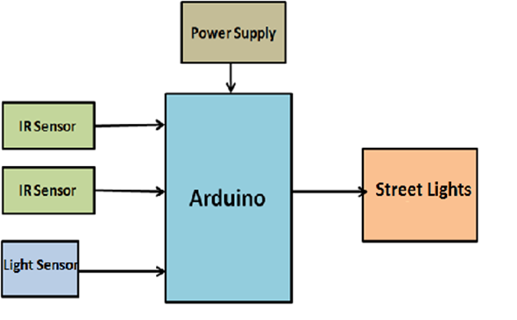

**Fig. 1[UNO]**

**3.5 OBJECTIVE**

The main objective of this project is to implement an IoT based Automatic Street Lightning

System. As the traffic decreases slowly during late-night hours, the intensity gets reduced

progressively till morning to save energy and thus, the street lights switch on at the dusk and then switch off at the dawn, automatically. The process repeats every day. White Light Emitting Diodes (LED) replaces conventional HID lamps in street lighting system to include dimming feature. The intensity is not possible to be controlled by the high intensity discharge (HID) lamp which is generally used in urban street lights. LED lights are the future of lighting because of their low energy consumption and long life. LED lights are fast replacing conventional lights because intensity control is possible by the pulse width modulation. This proposed system uses an Arduino board. Strings of LED are interfaced to the Arduino board. A programmed Arduino board is engaged to provide different intensities at different times of the night. This project is enhanced by integrating the LDR to follow the switching operation precisely and IOT to display the status of street on web browser and help in controlling it.

The main objectives are as follows:

* To avoid unnecessary Waste of light.
* Provide efficient, automatic and smart lighting system.
* Totally based on Renewable energy sources.
* Longer life expectancy.
* Energy saving.**[5]**

**3.6 CONCLUSION**

In this chapter we learnt about the need of this project and the problem it solves by getting replaced by the traditional model, hence increasing the effectiveness of the system. We took a look on the major problem faced by the current using model and the wastage/excess resource it uses in order to give the results, and we looked at some data showing the need of reducing this resource usage in order for fulfilling the other needs of the society.

**4. METHODOLOGY**

**4.1 INTRODUCTION**

Methodology involves algorithm and flowchart of how the control of the program flows upon execution, how the system was designed using various components, level by level working state of the model, and features of the model developed by our team. This chapter also gives you information about the processor (Arduino UNO) that we used in our system. All the information regarding the specification, physical characteristics, memory and operating power of the processor used is discussed in the chapter ahead.

**4.2 PROPOSED WORK**

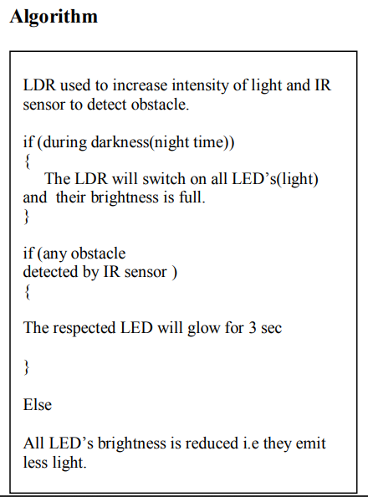

**FLOW CHART:-**

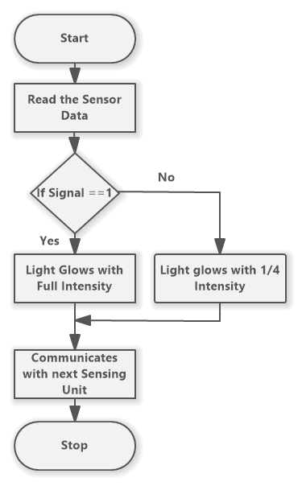

**Fig.2**

**4.3 SYSTEM DESIGN**

***4.3.1 FUNCTIONAL SPECIFICATION OF SYSTEM***

***Data flowchart diagram:-***

**LEVEL 0:-**

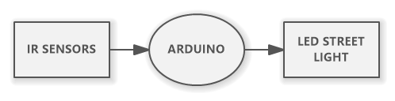

**Fig:3 [level 0]**

**LEVEL 1:-**

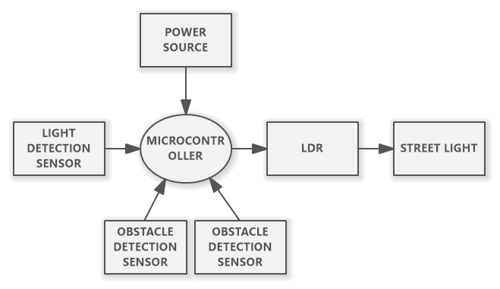

**Fig.4 [level 1]**

**LEVEL:-2**

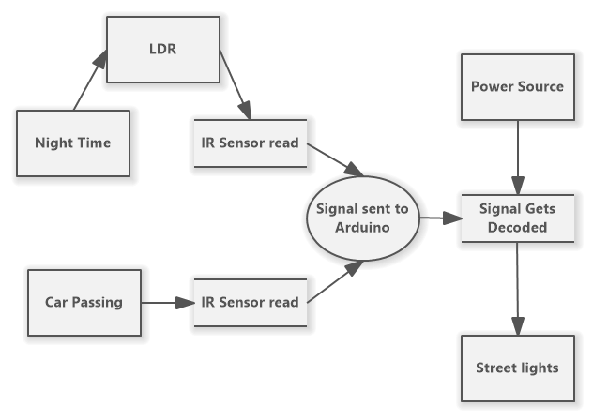

**Fig.5[level 2]**

**LEVEL 3:-**

**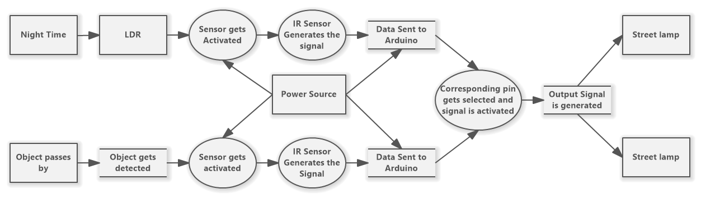  
Fig.6[level 3]**

***Flow Chart:-***

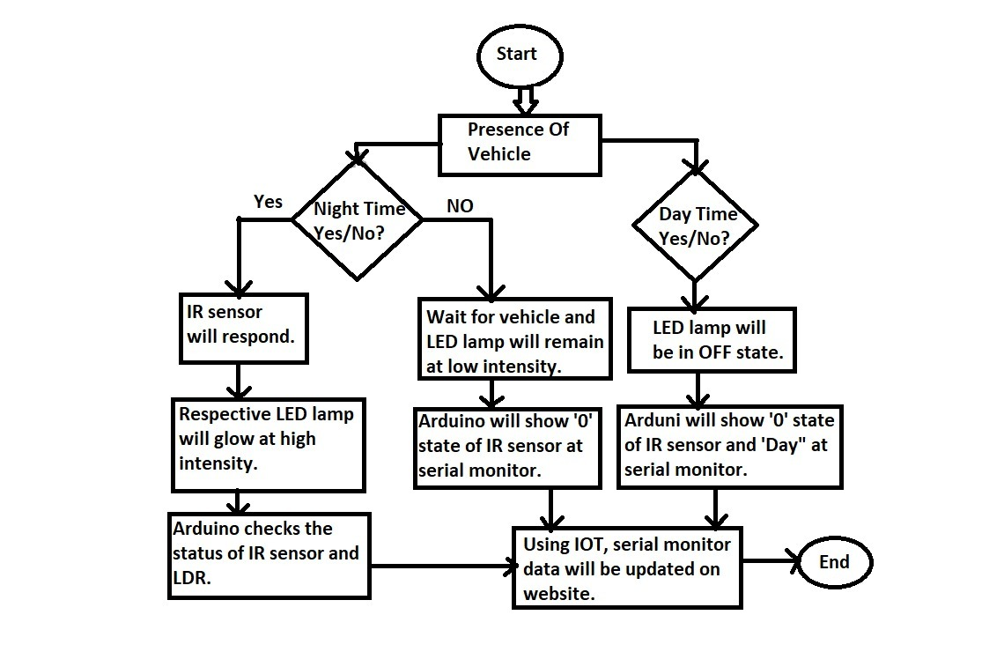

**Fig.7[Flow chart of smart street light]**

**4.4 FEATURES**

Needs no manual operation for switching ON and OFF. When there is a need of light it automatically switches ON. When darkness rises to a certain level then sensor circuit gets activated and switches ON and when there is other source of light i.e. daytime, the street light gets OFF. The sensitiveness of the street light can also be adjusted. In our project we have used six LEDs as a symbol of street lamp, and for high power switching we have connected Relay (electromagnetic switch).

The output has only two states high and low and cannot remain in any intermediate stage. It is powered by an AC source.

LDR (Light Dependent Resistor) is a special type of resistor whose value depends on the brightness of the light which is falling on it. It has resistance of about 1 mega ohm when in total darkness, but a resistance of only about 5k ohms when brightness illuminated. It responds to a large part of light spectrum. Since, voltage is directly proportional to conductance so more voltage we will get from this divider when LDR is getting light and low voltage in darkness.

As soon as any obstacle is detected by the infrared sensor, the light and the bulb turns ON and remains in that state right up until that vehicle is passed through.

Day and night detection is done extensively that is, no unnecessary use of street lights and no unnecessary wastage of energy and resources.

Moreover, a constant supply of LED and bulb output is provided using relay along the path of traversal of the automobile. Which in turn, keeps turning on the nearest LED and the corresponding bulb also switches on just when the vehicle is about to pass through the street light.**[3]**

**4.5 COMPONENT USED**

***i. LED :***

Light emitting diodes (LEDs) are semiconductor light sources. The light emitted from LEDs varies from visible to infrared and ultraviolet regions. They operate on low voltage and power. LEDs are one of the most common electronic components and are mostly used as indicators in circuits. They are also used for luminance and optoelectronic applications.

Based on semiconductor diode, LEDs emit photons when electrons recombine with holes on forward biasing. The two terminals of LEDs are anode (+) and cathode (-) and can be identified by their size. The longer leg is the positive terminal or anode and shorter one is negative terminal.

The forward voltage of LED(1.7V-2.2V1is lower than the voltage supplied (5V) to drive it in a circuit. Using an LED as such would burn it because a high current would destroy its p-n gate. Therefore a current limiting resistor is used in series with LED. Without this resistor, either low input voltage (equal to forward voltage) or PWM (pulse width modulation) is used to drive the LED.

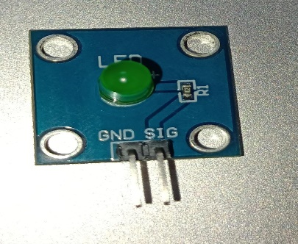

**Fig.8[LED]**

***ii. Motion Detection :***

According to problem statement (2) all the classical street lights are remain switched on from 6 pm to 6 am whether there is a pedestrian or vehicle is present or not present of any activity. The most probable peak time of movement is from 6 pm to 10 prn in a smart city; so after 10pm all the street lights are glowing at its full intensity which leads to loss of enormous amount of energy. So to overcome this problem if we can install a small motion detection device which will control the street light to glow at its 1OO% only in the presence of any activity in the street. To overcome this problem we can use IR sensor or proximity sensor or photoelectric beam detector or obstacle detection sensor.

***iii. LDR:***

LDRs or Light Dependent Resistors are very useful especially in light/dark sensor circuits. Normally the resistance of an LDR is very high, sometimes as high as 1000000 ohms, but when they are illuminated with light resistance drops dramatically. Electronic onto sensors are the devices that alter their electrical characteristics, in the presences of visible or invisible light. The best-known devices of this type are the light dependent resistor (LDR), the photo diode and the phototransistors. Light dependent resistor as the name suggests depends on light for the variation of resistance.

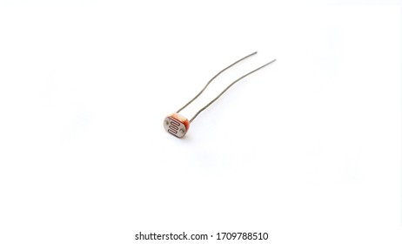

**Fig.9[LDR]**

***iv. lR Sensor :***

An infrared Sensor is an electronic device that emits in order to sense sorne aspects of the surrounding. An lR sensor can measure the heat of an object as well as detect the motion. Usually in the infrared spectrum, all the object radiate some form of thermal radiations. These type of radiations are invisible to our eyes that can be detected by an infrared sensor. The emitter is simply an lR LED and the detector is simply an lR photo diode which is sensitive to lR light of the same wavelength as that emitted by the lR LED. When lR light falls on the photodiode, the resistances and these output voltage, change in proportion to the magnitude of the lR light received

***a. Light Detection Sensor:***

A Light Detector or a Light Sensor is a device or circuit that detects the intensity of the light incident on it.

All these devices are called as Photoelectric Devices as they convert light energy to electric energy. These Light Detectors or Sensors can detect different types of light like visible light, ultraviolet light, infrared light etc.

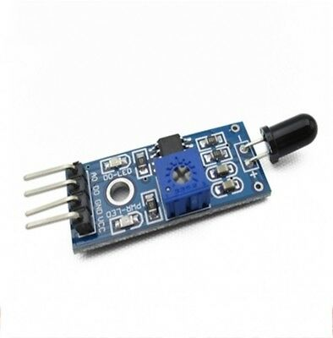

**Fig:10[light detect sensor]**

***b. Obstacle Detection sensor***

A Obstacle detection sensor is a device which sense the presence of object around it and send a signal when any object passes by it. Depending on the connections it work in both way i.e. ON when any object is detected, and OFFF when no object is detected, or Vice-versa

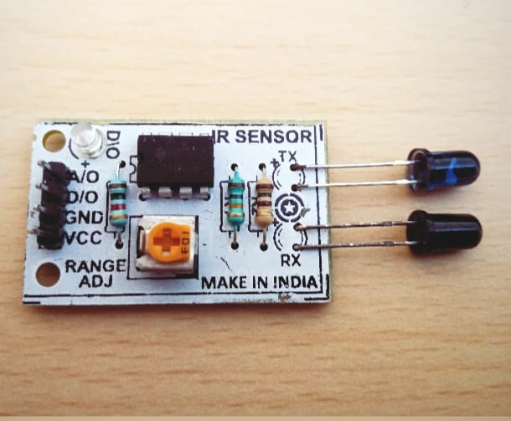

**Fig.10[obstacle detection sensor]**

***v. Bread Board :***

A breadboard is a widely used tool to design and test circuit. You do not need to solder wires and components to make a circuit while using a bread board. It is easier to mount components & reuse them. Since, components are not soldered you can change your circuit design at any point without any hassle. It consist of an array of conductive metal clips encased in a box made of white ABS plastic, where each clip is insulated with another clips. There are a number of holes on the plastic box, arranged in a particular fashion. A typical bread board layout consists of two types of region also called strips. Bus strips and socket strips. Bus strips are usually used to provide power supply to the circuit. It consists of two columns, one for power voltage and other for ground.Socket strips are used to hold most of the components in a circuit. Generally it consists of two sections each with 5 rows and 64 columns. Every column is electrically connected from inside

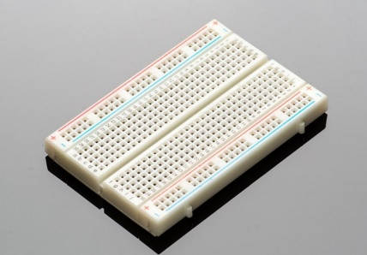

**Fig:11 [bread board]**

It helps in providing the required energy supply in order for proper functioning of our model, and it consist of pack of cells which with the help of an battery container is able to supply the required power

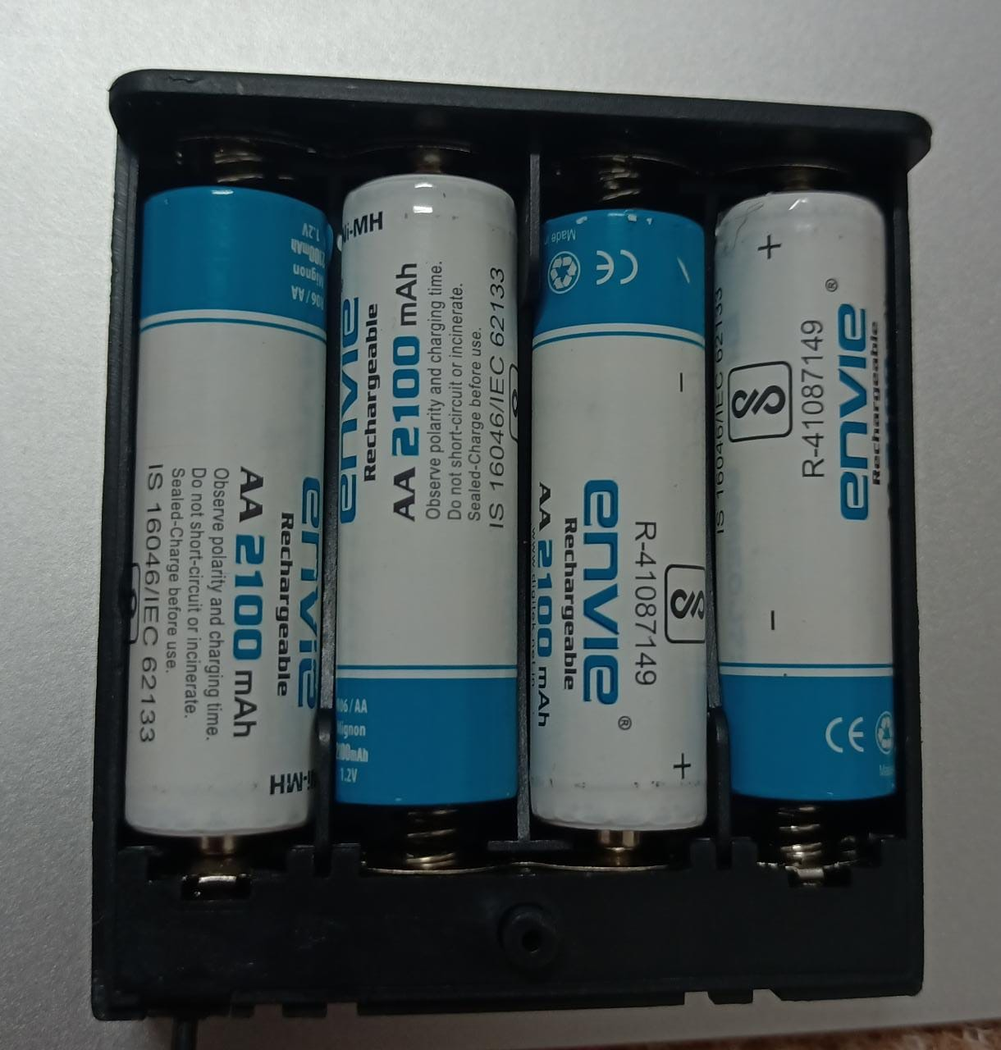

**Fig.12[battery]**

***vi. Jump Wires:***

A jump wire (also known as jumper, jumper wire, jumper cable, DuPont wire or cable) is an electrical wire, or group of them in a cable, with a connector or pin at each end (or sometimes without them – simply “tinned”), which is normally used to interconnect the components of a breadboard or other prototype or test circuit, internally or with other equipment or components, without soldering.

Individual jump wires are fitted by inserting their “end connectors” into the slots provided in a breadboard, the header connector of a circuit board, or a piece of test equipment.

There are different types of jumper wires. Some have the same type of electrical connector at both ends, while others have different connectors. Some common connectors are:

Solid tips – are used to connect on/with a breadboard or female header connector. The arrangement of the elements and ease of insertion on a breadboard allows increasing the mounting density of both components and jump wires without fear of short-circuits. The jump wires vary in size and colour to distinguish the different working signals.

Crocodile clips – are used, among other applications, to temporarily bridge sensors, buttons and other elements of prototypes with components or equipment that have arbitrary connectors, wires, screw terminals, etc.

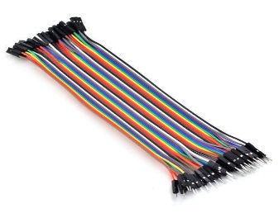

**Fig.13[ male -female wire]**

**4.6 OVERVIEW ON ARDUINO UNO**

The Arduino UNO is Atmega328 datasheet based microcontroller that has 5 analog inputs, 8 digital outputs and 5 PWM outputs. Lt has a reset button and 16 MHz ceramic resonator with an usb connection facility along with a power jack. **[9]**

“Uno” implies one in ltalian and is named to stamp the forthcoming arrival of Arduino 1.0. The Uno and version 1.0 will be the reference renditions of Arduino, making headway. The Uno is the most recent in a progression of USB Arduino sheets, and the reference model for the Arduino stage.

***Specifications:***

|  |  |
| --- | --- |
| Microcontroller | Atmega328 |
| Operating Voltage | 5v |
| Input Voltage(recommended) | 7-12V |
| Input voltage(limit) | 6-20V |
| Digital I/O pins | 14 |
| Analog Input Pins | 6 |
| DC current per I/O pins | 40ma |
| DC Current for 3.3V pins | 50ma |
| Flash Memory | 32 KB |
| SRAM | 2 KB |
| EEPROM | 1 KB |
| Clock speed | 16MHz |
| Length | 68.6mm |
| Width | 53.4mm |
| Weight | 25g |

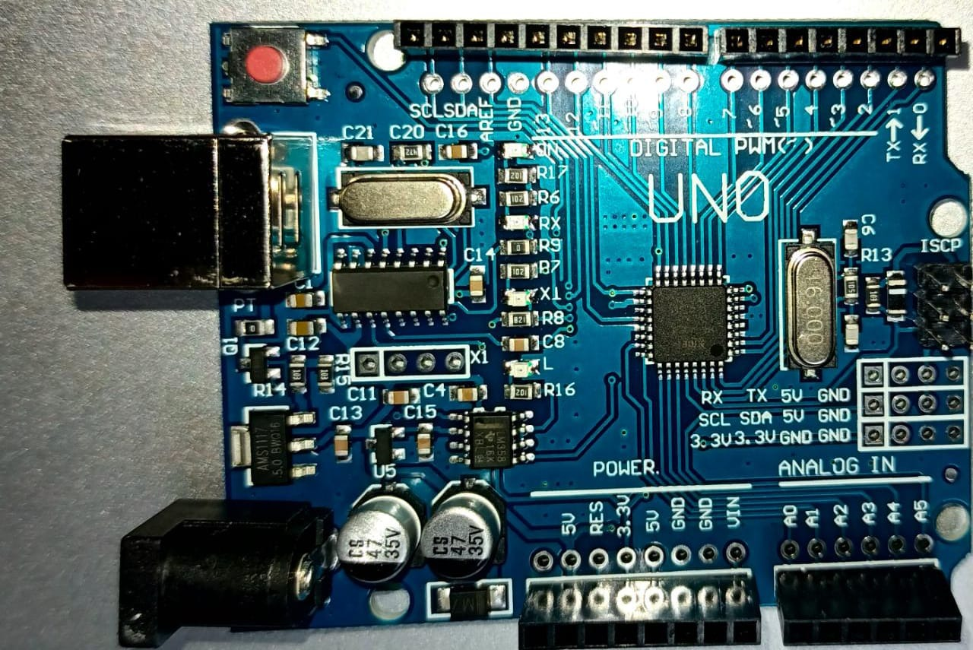

**Fig.14[UNO]**

***Physical Characteristics :***

The greatest length and width of the Uno PCB are 2.7 and 2.L inches individually, with the USB connector and force jack augmenting past the previous measurement. Four screw gaps permit the board to be connected to a surface or case. Note that the separation between advanced pins 7 and 8 is 160 mil (0.16”), not an even numerous of the 100 mil dispersing of alternate pins.[3]

***USB Overcurrent Protection :***

The Arduino Uno has a resettable poly-fuse that shields your PC’s USB ports from shorts and overcurrent. Albeit most PCs give their own particular inner insurance, the fuse gives an additional layer of security. In the event that more than 500 mA is connected to the USB port, the circuit will consequently break the association until the short or over-burden is uprooted. **[9]**

***Memory:***

* The Atmega328 has 35 KB (with 0.5 KB utilized for the boot loader) which includes
* 2KB for SRAM
* 1KB for EEPROM

***Power :***

It can only works on 7-L2 volts which can be possible via USB connection from the system. We can give supply to it by using a battery between Vin and GND. Lt also provides a IOREF pin to decide whether it should work on 5v or 3.3v.

***Input and Output :***

* Serial: O (RX) pin to receive serial data.
* Serial: 1 (TX) pin to transmit serial data.
* External Interrupts: Pin 2 and 3 are used to activate interrupt command.
* PWM: 8-bit PWM outputs are provided in -3,-5,-6,-9,*IO,-IL
* LED: 13. The built-in-led shows whether Arduino is on or off.
* It has 6 Analog input named A0,A1,,A2,A3,A4,A5.

**4.7 CONCLUSION**

In this chapter, we looked at the major data flow of the circuit how to model is receiving its data and using that data to get the desired results, it is shown using flowcharts and DFD’s, we also looked at some major component used in this project in order for its proper functioning, such as, LED, LDR, jumper wires, power source, ir sensors. We also looked at the arduino Uno processor which is the microcontroller used in the circuit, it is manually programmed with the help of arduino IDE, and we also looked at its physical configuration and its working, how it will be communicating with the circuit and its specifications.

**5. IMPLEMENTATION**

**5.1 INTRODUCTION**

This chapter deals with the discussion of how the circuit was designed and implemented. It involves the information related to working of the circuit and the result that are expected as outcome of this project. The pseudocode that is used for programming our processor used in our project is also included in this section.

**5.2 CIRCUIT DESIGN**

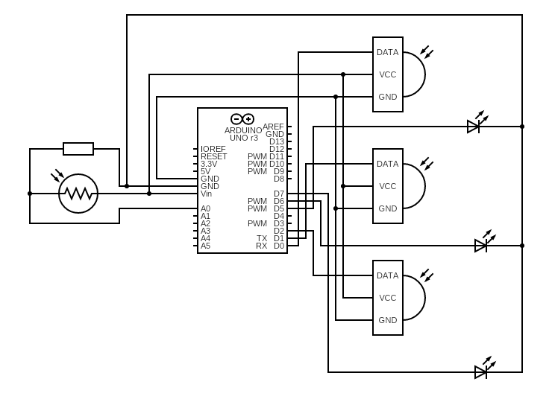

**Fig.15[ Rough design of UNO]**

**5.3 IMPLEMENTATION**

* We have used one LDR circuit to distinguish between the day and night. LDR with a small register in series is connected across the 5V and GND of the Arduino Uno and from the midpoint of the LDR potential divider circuit the output of the circuit is feed to A0 of the Arduino which turn on all the street lights which are represented by Led connected to the output pin (ie: 5 ,6 ,7 ,8,9 ,1O ,71,,12, 13 ) .
* LDR is a special type of resistor whose value depends on the brightness of the light which is falling on it. Lt has resistance of about 1M-ohm when in total darkness but a resistance of only 5 k-ohm when brightness is illuminated. The voltage is directly proportional to the conductance so more voltage we will get when there is sunlight and vice-versa and then we have to set a reference value for the switching actions of the Led. The reference value is set to 500(baud rate).
* Four infrared receiver and sender circuits are made to detect the movements and output from the receiver is fed to the input terminal (ie. !,2,3,41which corresponds to the led connected to 5,6,7,8,9,L0,LI,L2,L3 respectively. All the object sensors are connected between 5V and GND of the Arduino UNO. **[9]**

***Working of the circuit :***

* The output from the LDR is connected to the A0 and initially LDR flag and LDR value is set to zero. The value of LDR reference value is initialized and set to 500(baud rate). Lf the Arduino UNO reads any value from LDR whose value is less than the LDR reference value than it will turn on the street lights.
* The output from lRL and lR2, lR3, and object lR4 are connected to the pin L,2,3,4 and reference value of all sensor is set to 500(baud rate).
* Another four proxy value for each object sensor are set to zero and if any object sensor detects any presence of objects then Arduino UNO compares the value with the object reference value. Lf the sensed value is less than the reference value it will glow with 100% of its intensity otherwise LEDs will be off.
* The first and the last LED glows continuously to detect the start and end of the road. **[9]**

***Result:-***

The project aims were to reduce the side effects of the current lighting system and find a Solution

to save power. In this project the first thing to do is to prepare the inputs and outputs of the

system to control the lights. The project shown in the figure has been implemented and works as

expected and will prove to be very useful. The prototype of the system with obstacle detection on

the street through IR sensor where the IR Sensor detects the obstacle and switch ON the Lights.

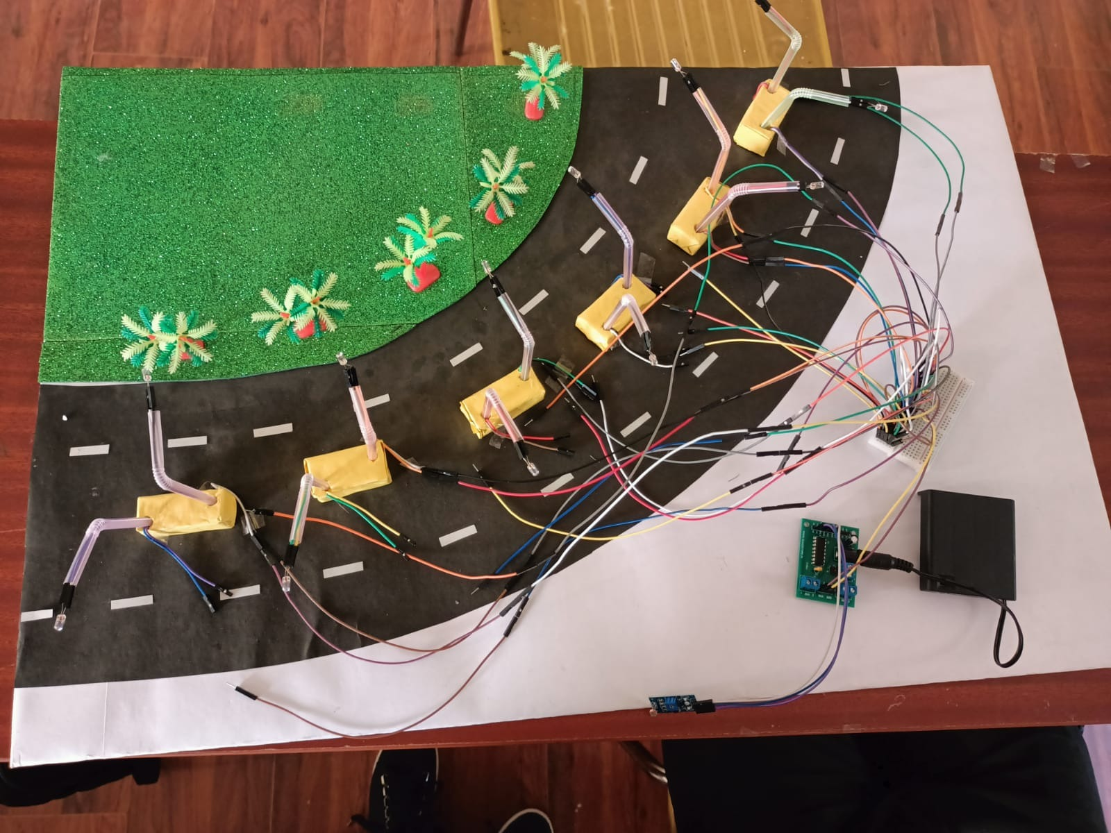

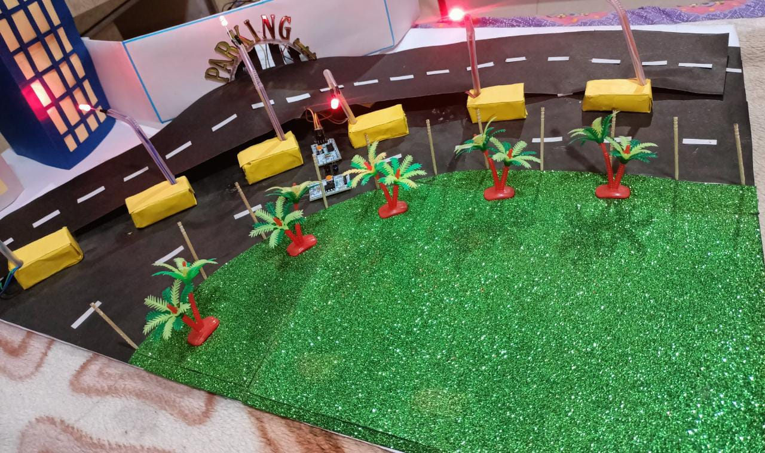

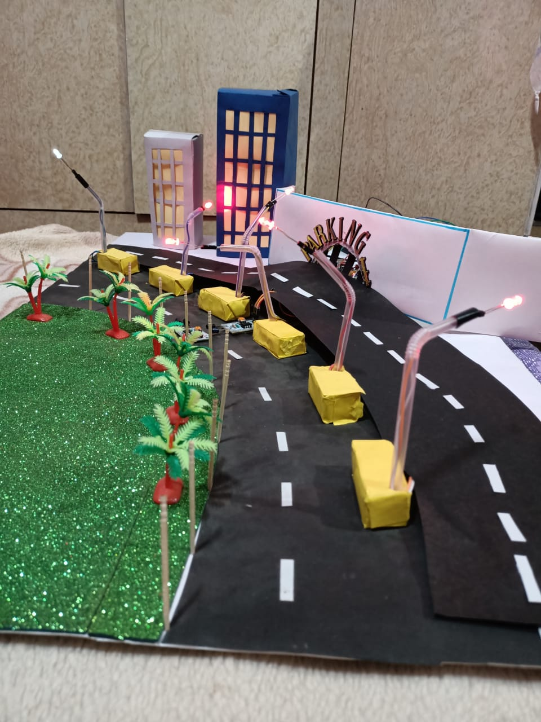

* 1. **CONCLUSION**

This chapter was all about the implementation of the circuit how the connections are made and how it gets the required power to operate properly, it includes the clear circuit diagram of the circuit implemented showing the correct connections of the circuit, it also shows the proper connection of the sensors in order for working in the desired manner, we also showed the proper working of the circuit how to data/signal is received and the Led responds to the corresponding signal.

**6. RESULT AND DEMONSTRATION**

**Observations and Outcomes :**

For a comparative study we have to take the following assumptions:**[1]**

**Assumptions:**

* Suppose a 10 km long one-way street contains 500 street lights and the nominal range of all the street lights are 20 meter.
* Af l the street lights are supposed to glow for a period of L2 hour from 6 pm to 6 am.
* One street light is supposed to consume 1 kwh power for a period of t hour when it glows with its maximum intensity so that one street light consumes maximum 12kwh in a day.
* So 500 street lights consume maximum L2kwh*500=6000kwh power in a day.
* Each IR sensor if blocked than two street light glows.

***Case-1: (Let one vehicle is in motion during night)***

If two Street light glows per one IR sensor

Then power consumed by two Street light = 2*1kWh

= 2kWh

Maximum of only two street light glow for one vehicle movement.

Therefore, Total power consumed for 12 hrs. = 2kWh*12

= 24 kwh

Total power saved = 6000kWh - 24kwh

= 5976 kwh

***Case-2: (from 5am to 6am and 12 pm to 1 am; let only 10 vehicles are in motion)***

lf 10 vehicle crosses the street light one by one; than total of 20 street light glows per 10 lR sensor

Therefore, power consumed by 20 Street light = 20kWh

Total power consumed in 12 hrs = 20kwh*12

= 24O kwh

So, total power saved = 6000kWh - 24A kwh

= 5760 kwh

***Case-3: (from 10pm to 12am; let only 100 vehicles are in motion)***

lf 100 vehicle crosses the street light one by one; than total of 200 street light glows per 1.00 lR sensor

Therefore, power consumed by 200 Street light = 200kWh

Total power consumed in 12 hrs = 200kwh*12

= 2400 kwh

So, total power saved = 6000kWh - 2400 kwh

= 3600 kwh

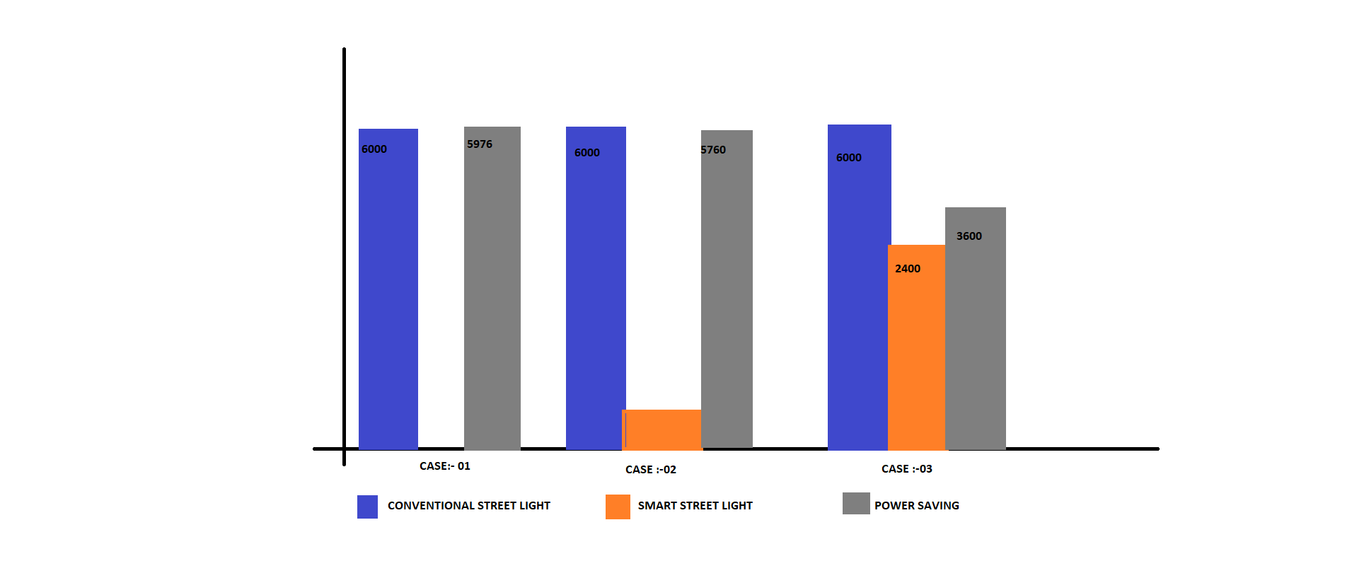

**7. PROJECT RELEVANCE**

**7.1 INTRODUCTION**

This chapter walks you through the facts that clearly state how our project which is “smart street lightning system” is going to contribute to the society in terms of reducing the cost of operation of street lights and also reducing the manual labour by making them automated. Going through this section will also inform you about the technical novelity and utility of the project, objective and relevance of the project and the expected outcome of the project.

**7.2 CONTRIBUTION OF PROJECT TO THE SOCIETY**

Street lighting is an important community service, but it can consume as much as 40 percent of a city’s energy budget. Legacy street lights are failure prone and costly to manage, which add to lighting costs. Consequently, street lighting has emerged as a leading smart city application. By replacing existing street lights with LED-based lamps, utilities and other street light operators can cut energy and operations costs by 50 percent or more. Networking those LEDs delivers an even faster return on investment (ROI), taking the payback period down to 6 vs. 8 years, as a result of features such as remote management and faster outage response. Understanding the operational details of networked LEDs and comparing those benefits and costs to traditional lighting lays the foundation for building a business case to upgrade street lights. The hard dollar savings in energy and operational costs make the case for replacement, and networked LEDs provide additional community value as well.**[4]**

**7.3 OBJECTIVE AND RELEVANCE OF PROJECT:-**

The main objective of this project is to implement a IoT based Automatic Street Lightning System. As the traffic decreases slowly during late-night hours, the intensity gets reduced progressively till morning to save energy and thus, the street lights switch on at the dusk andthen switch off at the dawn, automatically. The process repeats every day. White Light Emitting Diodes (LED) replaces conventional HID lamps in street lighting system to include dimming feature. The intensity is not possible to be controlled by the high intensity discharge (HID) lamp which is generally used in urban street lights. LED lights are the future of lighting because of their low energy consumption and long life. LED lights are fast replacing conventional lights because intensity control is possible by the pulse width modulation .This proposed system uses an Arduino board. Strings of LED are interfaced to the Arduino board. A programmed Arduino board is engaged to provide different intensities at different times of the night .This project is enhanced by integrating the LDR to follow the switching operation precisely and IOT to display the status of street on web browser and help in controlling it.

The main objectives are as follows:

* To avoid unnecessary Waste of light.
* Provide efficient, automatic and smart lightning system.
* Totally based on Renewable energy sources.
* Longer life expectancy.
* Energy Saving.

**7.4 TECHNICAL NOVELITY AND UTILITY**

the street light system is also depends on the obstacle cross across the street light .If the obstacle is cross the street light then only at that instant light will glow otherwise it will be in off condition this feature will help in consumption of electricity .whole over the night the all street lights are usually glow which may the one vital cause of wastage of electricity. this feature will prevent the glowing of light whole over the night. This development will continue in the coming years based on increased connectivity and industrial internet of things (IIot) solutions becoming a key element in most smart city strategies the globe. Smart street lights can transform the way municipalities manage cities, while delivering enormous savings. With street lighting accounting for nearly 40 percent of many cities’ total energy costs, local governments and utility providers are seeking new ways to decrease energy usage and reduce costs. Switching from halogen to LED luminaires can help achieve that goal by delivering immediate savings of 50 to 80 percent through reduced energy use. Moreover, installing smart LEDs can generate an additional 10 to 20 percent savings by adjusting output to ambient light levels, dimming or brightening as needed.1 They can also be set to turn on only when they detect motion, and then dim or turn off after a specific amount of time.

**7.5 EXPECTED OUTCOMES**

***Energy savings*** The energy savings for the two scenarios compared to the energy consumption today are approximately 73.5 % and 79.2 %, thus it is profitable to invest in LED technology . The LED lights have lower power than therefore the energy consumption is reduced. An energy saving of 79.2 % seems reasonable since the energy saving in Sala is 77.8 %. There is a limitation in the calculations when looking at the amount of each armature type in Uppsala. The number of armatures are based on a distribution over the used armatures in Sala, which might be slightly different from the types and amounts that would be applied to Uppsala. Data over the types of armatures used today could have made the calculations more realistic for Uppsala. But limitations in data from Uppsala municipality about the 24 667 armatures advocated the usage of a distribution table. **[1]**

***Economic savings***:- The reduction of maintenance costs is a big part of the annual savings for LED with smart control system. It is based on a prognosis from SHE-e and Philips which can be

an optimistic number. The reduction of the maintenance cost for LED with stand-alone system is as described in section 3.2 an assumption based on the differences in workload for the two scenarios. Due to the limited data for LED stand-alone systems, the assumption is hard to verify. This may affect the result for the scenario**. [1]**

**7.6 CONCERN RELATED TO PROJECT:-**

***7.6.1 social relevance:-***

* Solar street light is independent of grid as a result of this operating cost is much low.
* Maintenance cost is much low compared to conventional street light.
* Intensity of LED can be controlled effectively without changes in its light color.
* Risk of accidents is very low.
* It is environmental friendly, no harmful emissions.
* Longer life compared to conventional street lights.
* Power consumption is much lower.
* LDRs are sensitive, inexpensive and readily available devices. They have good power and voltage handling capabilities, similar to those of a conventional resistor.

***7.6.2******Environmental sustainability :-***

**Energy savings**: Typically, the largest benefit of networking LED street lights is lower energy costs, which result from the following features. **Low wattage**: LEDs provide significant energy savings by delivering the same or enhanced quality light at lower wattages than legacy bulbs. **Dimming**: Due to their high light output, LED lamps can be dimmed as much as 50 percent when first installed with minimal compromise in light output. In addition, operators can schedule lamps to dim as circumstances allow, such as at low traffic times, in unpopulated areas the middle of night, etc. The city of Brittany, France, for example, dims its street lights by 60 percent between 11 p.m. and 5 a.m. to save energy. **Reduced burn time**: With on/off scheduling capabilities, operators can easily modify street light operation to coincide with changing sunrise/sunset times, reducing lamp burn time. As a result of these features, networked LEDs can reduce energy use for street lighting by 60 to 74 percent. For example, Los Angeles and Oslo, Norway, which have launched smart street light projects, have seen energy savings of 63 and 62 percent, respectively.

***7.6.3 Ethical, legal and cultural aspect :-***

Humans are not perfect. When decisions have to be made, a lot of factors usually come into the picture, some of which may lead to biased or discriminatory actions. In a smart city, there is more data to deal with than anyone can imagine. The availability of this data increases the possibilities of misuse by those who have it. Observing ethical conduct becomes more necessary than ever. Rules, policies, regulations, and laws can limit misconduct, but there is always room for major problems given the vast amount of data available and the deep penetration of the data collection process in every aspect of residents’ lives. In controlling this data, its flow and use need to be considered not only from the technical perspective (i.e., proper storage, access, security, etc.), but also from the ethical perspective. Ensuring proper use and limiting the possibilities of ethical misconduct is the key to implementing a successful livable smart city.**[6]**

**8. CONCLUSION AND FUTURE SCOPE**

**8.1 INTRODUCTION**

This chapter finally concludes the idea of our project .The system that is used will conserve energy and save environment which indirectly leads our country to the development. It is economical and easy to implement and replace the current system. The circuit which is used is totally based on arduino which here works as a micro-controller using the input from LDR. The system can be easily implemented on our Indian streets which needs this type of system as soon as possible. This section also walks you through the limitations of the system made by our team and the future advancement that could be done on the project.

**8.2 CONCLUSION**

This project report gives the detail study of the "Smart Street Light System". The construction, working principle, implementation of the project is given throughout this report. Circuit meets expectations appropriately to turn road light on/off depending on the movement of the vehicle. LDR sensor senses the day or night time. The lR sensor senses the motion of the vehicle. The road lights have been effectively controlled by Arduino UNO. With orders from the controller, the lights will be ON in the spots of the movements. Besides the downside of the road light framework utilizing timer controller has been succeeded, where the framework relies on upon photoelectric sensor. At long last this control circuit can be utilized as a part of a long roadway between the urban areas as well as the rural areas.

The results of our project work supports our hypothesis that the Smart Street Light circuit would solve the power consumption problem. The final conclusion drawn from our project work is that the circuit is very efficient and it can be used in street of India.

**8.3 LIMITATIONS**

The project heavily relies on IR sensors and its working. In a scenario where the car is moving with some higher speeds or better yet, multiple cars are moving with high speeds, incompetence in the IR sensors increases and the results might not be in our favor that is, faulty results can be the outcome.

Moreover, the signal strength, which has been amplified using relay module or transistor is heavily dependent on relay-used as a switch which in itself, is a multiport repeater that is, in the case of signal breakage due to interference by EM waves (Electromagnetic Waves) it would replicate the signals and not lose the signal strength or its highest intensity.

And, better prospects for its implementations in society that is, its primary implementation in parks, housing colonies, government quarters should be thought of and some action plan along with the initiative should be ready.

Prospects for gathering real-time traffic analysis by using various Google services such as GPS, Google Maps etc.

**8.4 FUTURE GOALS**

1. We can use technologies like GSM to make a network and using this network, we can interconnect all the street lamps.

2. This networked LED system can be controlled from a control room. Several PIR sensors can be used to decrement or increment the intensity of the lamps.

3. The system architecture of the intelligent street light system will consist of IR sensors, LDR, PIC16F877A microcontroller, Relay, UART and Wi-Fi Module. A UART (Universal Asynchronous Receiver/Transmitter) is the microchip with programming that controls a computer's interface to its attached street light system.

4. We can share the network data to traffic control units. The data from this network can be used in various fields.

5. As we’re using LED in place normal street lamps, we can design a mechanism as to put the LED’s at 50% of their intensity, as they are much brighter than normal street lamps.

6. We can make the use of solar panels and make the street lamp more power efficient in terms of environment friendly.

7. We can also Share this data with multiple stakeholders.

8. Prospects for gathering real-time traffic analysis by using various Google services such as GPS, Google Maps etc.

**REFRENCES**

**[1]** Syed Najeeb Ali Kazmi, Abasin Ulasyar, Muhammad Faisal Nadeem Khan, "IoT based Energy Efficient Smart Street Lighting Technique with Air Quality Monitoring", *Open Source Systems and Technologies (ICOSST) 2020 14th International Conference on*, pp. 1-6, 2020. [seen on 27.10.21 17:30]

**[2]** R. Majumdar, A. Srivastava, D. Tulsian and V. P. Mishra, "IOT based Street Light Controlling Mechanism," 2019 International Conference on Computational Intelligence and Knowledge Economy (ICCIKE), 2019, pp. 433-436, doi: 10.1109/ICCIKE47802.2019.9004248. [seen on 17.08.21 11:10]

**[3]** Ashish Pandharipande, Paul Thijssen, "Connected Street Lighting Infrastructure for Smart City Applications", *Internet of Things Magazine IEEE*, vol. 2, no. 2, pp. 32-36, 2019[seen on 05.10.21 15:30]

**[4]** P. Arjun, S. Stephenraj, N. N. Kumar and K. N. Kumar, "A Study on IoT based Smart Street Light Systems," 2019 IEEE International Conference on System, Computation, Automation and Networking (ICSCAN), 2019, pp. 1-7, doi: 10.1109/ICSCAN.2019.8878770.[seen on 12-10-21 12:00]

**[5]** Saba Latif, Hamra Afzaal, Aniqa Rehman, Nazir Ahmad Zafar, "Deterministic Formal Modeling of Smart Lightening System using Internet of Things", *Mathematics Actuarial Science Computer Science and Statistics (MACS) 2018 12th International Conference on*, pp. 1-6, 2018. [seen on 18.09.21 16:10]

**[6]** P. P. F. Dheena, G. S. Raj, G. Dutt and S. V. Jinny, "IOT based smart street light management system," 2017 IEEE International Conference on Circuits and Systems (ICCS), 2017, pp. 368-371, doi: 10.1109/ICCS1.2017.8326023. [seen on 15.09.21 12:30]

**[7]** B. Abinaya, S. Gurupriya and M. Pooja, "Iot based smart and adaptive lighting in street lights," 2017 2nd International Conference on Computing and Communications Technologies (ICCCT), 2017, pp. 195-198, doi: 10.1109/ICCCT2.2017.7972267. [seen on 10.09.21 12:00]

**[8]** N. Ouerhani, N. Pazos, M. Aeberli and M. Muller, "IoT-based dynamic street light control for smart cities use cases," 2016 International Symposium on Networks, Computers and Communications (ISNCC), 2016, pp. 1-5, doi: 10.1109/ISNCC.2016.7746112. [seen on 23.08.21 19:30]

**[9]** <https://www.arduino.cc/en/Guide/ArduinoUno>. [seen on 12.08.21 13:05]

**ANNEXURE**

int ir1=2;

int ir2=3;

int ir3=4;

int ir4=5;

int led1=6;

int led2=7;

int led3=8;

int led4=9;

int led5=10;

int led6=11;

int proxy1=0;

int proxy2=0;

int proxy3=0;

int proxy4=0;

void setup()

{

pinMode(ir1,INPUT);

pinMode(ir2,INPUT);

pinMode(ir3,INPUT);

pinMode(ir4,INPUT);

pinMode(led1,OUTPUT);

pinMode(led2,OUTPUT);

pinMode(led3,OUTPUT);

pinMode(led4,OUTPUT);

pinMode(led5,OUTPUT);

pinMode(led6,OUTPUT);

}

void loop(){

proxy1=digitalRead(ir1);

proxy2=digitalRead(ir2);

proxy3=digitalRead(ir3);

proxy4=digitalRead(ir4);

if(proxy1==HIGH)

{

digitalWrite(led1,HIGH);

digitalWrite(led2,HIGH);

digitalWrite(led3,HIGH);

}

else

{

digitalWrite(led1,LOW);

digitalWrite(led2,LOW);

digitalWrite(led3,LOW);

}

if(proxy2==HIGH)

{

digitalWrite(led2,HIGH);

digitalWrite(led3,HIGH);

digitalWrite(led4,HIGH);

}

else

{

digitalWrite(led2,LOW);

digitalWrite(led3,LOW);

digitalWrite(led4,LOW);

}

if(proxy3==HIGH)

{

digitalWrite(led3,HIGH);

digitalWrite(led4,HIGH);

digitalWrite(led5,HIGH);

}

else

{

digitalWrite(led3,LOW);

digitalWrite(led4,LOW);

digitalWrite(led5,LOW);

}

if(proxy4==HIGH)

{

digitalWrite(led4,HIGH);

digitalWrite(led5,HIGH);

digitalWrite(led6,HIGH);

}

else

{

digitalWrite(led4,LOW);

digitalWrite(led5,LOW);

digitalWrite(led6,LOW);

}

}